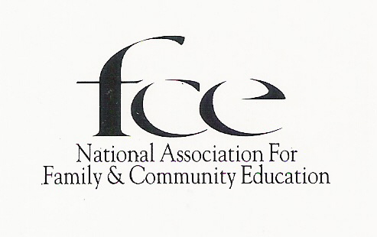

2019 Membership Form
***Type or Print Clearly in ink***
***Do Not Abbreviate City, County, Street or State Names***

Date______________ Current Member ID# Email_______________________________
First Name________________________ M.I.______ Last Name __________________________________
Mailing Address_________________________________________________________________________
City ___________________________________State ______________________Zip Code+4 ___________
Phone No ________________________________________Council _______________________________
Club Name ___________________________________Club County _______________________________

Family Membership: (Please list) Spouse Name _______________________________________________
Dependent Child(ren)________________________________________________________

Dues | Individual | Family | Senior  (80+ years) | Youth  Under  18
National | $ 20.00 | $ 30.00 | $16.50
State | $12.50 | $12.50 | $12.50
Council/County/Parish
Club
Total

Sign and send with total membership dues to Club Treasurer by _________________________.

New Member (Never belonged to FCE before)

Member Signature__________________________________________________________
Must be original signature, copies will not be accepted

Mission…To strengthen individuals, families, and communities
through continuing education, developing leadership, and community action.

